Exam Preparation
Test your tasks in the Judge system:
https://alpha.judge.softuni.org/contests/exam-preparation-ii/4455

Magic Numbers
Write a program that:
- Reads an integer number N from the console, always greater than or equal to 1
- Print all magic numbers in range [1; N] - separated by single space
- The number is magic when:
  - All of its digits are prime numbers
  - Sum of all digits is divisible by 2
- If the are no such numbers print "no"

Example
Input | Output | Comments
25 | 2 22 | We have to check numbers in range [1; 25]  Magic numbers in this range are 2 and 22.
100 | 2 22 33 35 37 53 55 57 73 75 77

Min / Max Values
Write a program that:
- Reads an array of integer numbers from the first line of the console, separated by single space
- Read an integer number N from the second line of the console
- Find max number in the first N elements in the given array
- Find min number in the first N elements in the given array
- Print max number and min number, each on separate line

Example
Input | Output | Comments
3 42 61 7 8 9 10 23  4 | 61  3 | First 4 numbers in the array are: 3 42 61 7  Max number is: 61  Min number is: 3
12 34 98 42 65 12  3 | 98  12 | First 3 numbers in the array are: 12 34 98  Max number is: 98  Min number is: 12

Unit Testing: Smallest Positive Number in List
Test a given method which takes a list of integers and returns a string message containing the smallest positive number in the list.
- If the list is null or empty, it should return "List cannot be empty.".
- If there are no positive numbers in the list (all numbers are negative or zero), it should return "No positive numbers found.".
- Otherwise, it should return "Smallest positive number is: {smallestNumber}".
The method is found in the NumberFinder.cs file
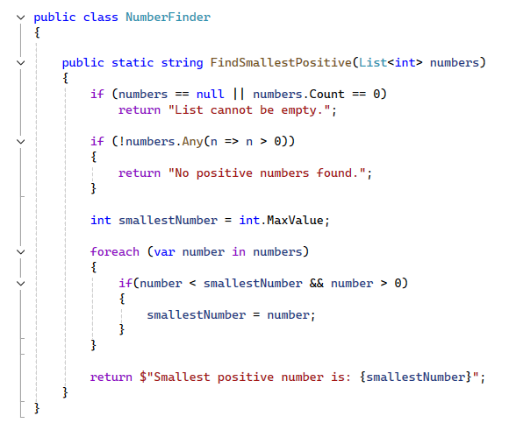
You are given a test file NumberFinderTests.cs containing 6 empty test cases. Implement all the cases:
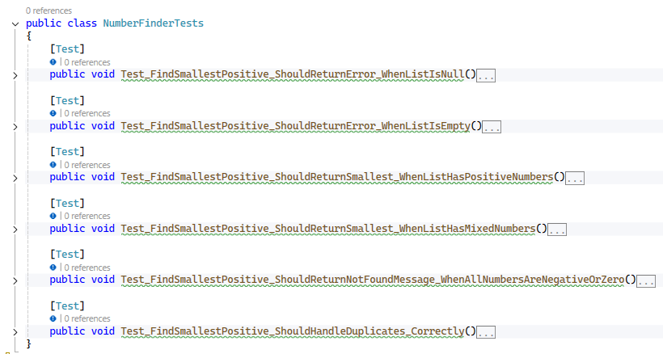
When you are ready make sure your tests run:
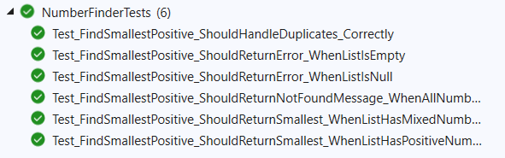
IMPORTANT: DO NOT REMOVE OR CHANGE ANY NAMESPACES AND USINGS.

Unit Test: Censor Word in Sentence
Test a given method which takes in two string parameters:
- a sentence (text input), and
- a word that should be censored in the sentence.
The method replaces every whole-word match of the given word with a sequence of asterisks (*), equal in length to the censored word.
All other words in the sentence remain unchanged.
The comparison should be case-insensitive (e.g., “Bad” and “bad” should both be censored).
Example:
"This is a bad word", "bad" → "This is a *** word"
string sentence = "This is a bad word";
string wordToCensor = "bad";

string expected = "This is a *** word";
If the sentence or the word is null or whitespace, the method should return a specific error message:
- if the sentence is null or whitespace, should return "Sentence cannot be empty."
- if the word is null or whitespace, should return "Word to censor cannot be empty."

The method is found in the TextCensor.cs file:
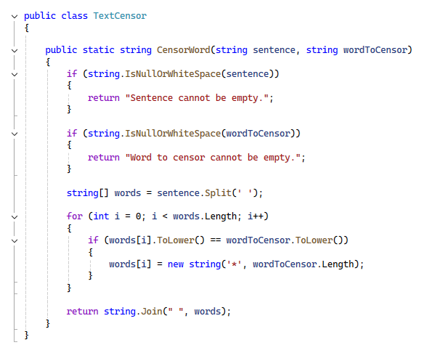

You are given a test file TextCensorTests.cs containing 8 empty tests. Implement all the unit tests:
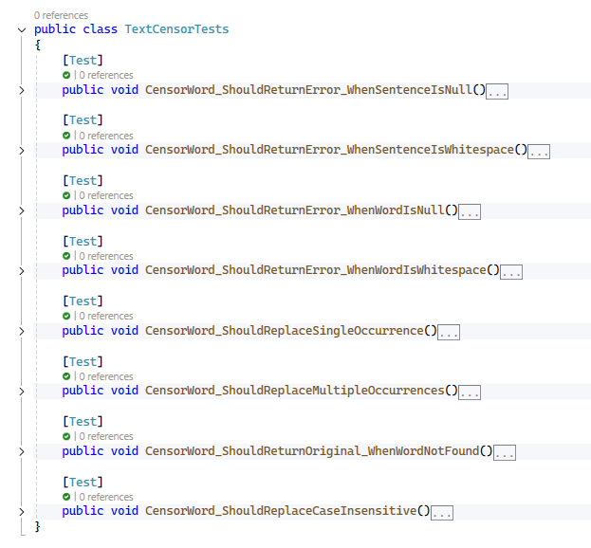
When you are ready make sure your tests run:
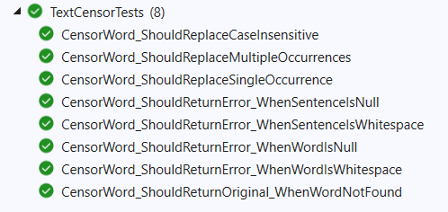
IMPORTANT: DO NOT REMOVE OR CHANGE ANY NAMESPACES AND USINGS.

